


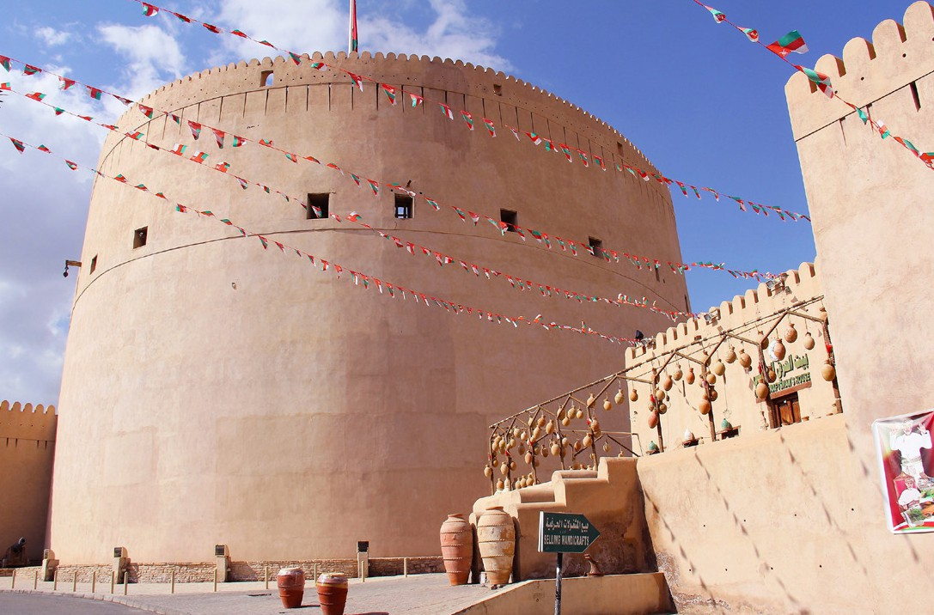


TRAVEL CHANGES LIVES
Want to go to Oman? Learn more at a meeting...
Trip:
Led by: Trip Date:
Meeting Date & Time: Meeting Place:
RSVP for the meeting here!
www.acis.com

