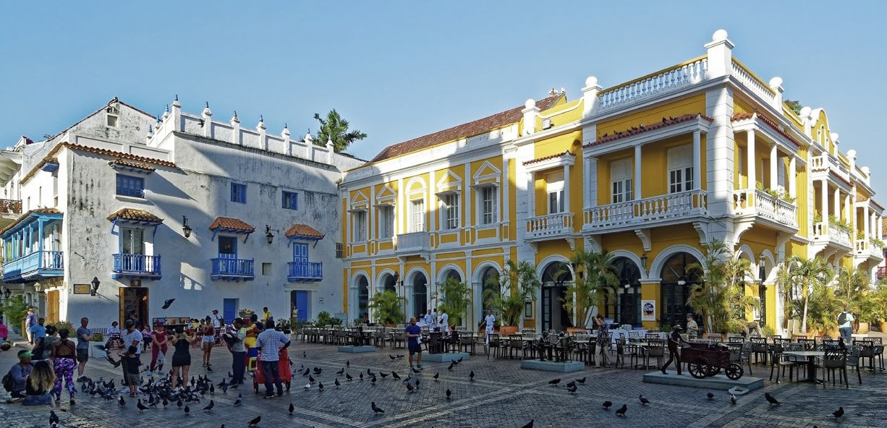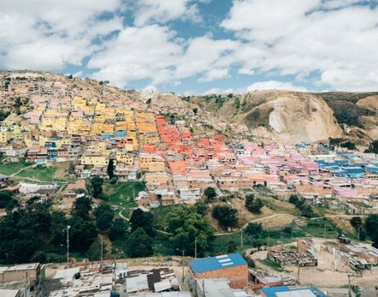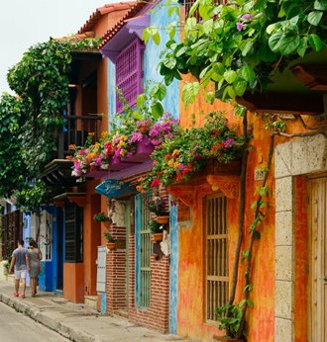



TRAVEL CHANGES LIVES

**Want to go to Colombia? Learn more at a meeting...**

Trip:

Led by:

Trip Date:

Meeting Date & Time: Meeting Place:

[www.acis.com](http://www.acis.com/)